Scenario Y Report

**< Nathan Yuen >, Group 19  
*Electronic and Electrical Engineering, UCL*

*Summary*—The aim of the project is to design and build a tin-can phone system which allows audio transmission within the range of voice frequencies and to characterise the system’s performance. The tin-can phone is a communication device which involves two tin cans connected by a wire. It is a device that allows sound to be heard at longer distances by transmitting the sound through a wire. This made communication more convenient in the 17th Century. Because of the natural acoustic response of the tin-can, human voice frequencies are able to be transmitted through the tin-can phone. However, frequencies other than the spectral resolution of the tin-can can be heard better in free space. Therefore, the gain is positive within the frequencies of the spectral resolution tin-can, while negative with frequencies outside the spectral resolution of the tin-can.

# Introduction

When sound travels through free space, air particles will collide with each other, passing on the vibration until it reaches the eardrum, allowing us to hear. However, being too far from the sound causes particles to lose energy and stop colliding as they reach the eardrum. Presently, mobile phones allow humans to communicate at very long distances, however this is not possible without electromagnetic waves. Despite that, we can increase the distance of communications using devices like a tin-can phone. The goal of this project is to design and build a tin-can phone, then compare audio transmission in the system with transmission in free space.

# Background

The transmission system contains two cups/cans joined together by a wire. We chose tin cans in our system as the spectral resolution of the cans lied in between the desired frequencies (Figure A1). When the first tin-can hears the signal, the cup will vibrate. These vibrations are transmitted to the wire, and it is passed along the wire until it gets to the opposite tin-can where the signal is received. To achieve the highest possible performance, we chose the thickest steel wire over nylon wire for the system. Although steel is seven times as dense as nylon, which decreases the speed of vibrations along the wire, steel is almost hundred times as elastic as nylon, increasing the speed of vibrations [1]. Humans can hear frequencies in the range of 20-20000Hz [2], however hearing is most sensitive in the frequency range of 300-3000Hz [3], which is the most optimum frequencies for communication.

# Results and Discussion

Our experimental system is two tins cans, where the bottom of the cans is joined together with a steel wire, 0.5mm in diameter. The system is placed on brackets which are clamped onto the table. The speaker playing the audio is placed next to one can while the opposite can is placed near a microphone connected to MATLAB recording the sound. The test audio chosen is a chirped gaussian pulse where the frequencies start at 400Hz and increases to 2000Hz. This covers the range of voice frequencies. The audio was recorded with and without the system in a silent room to compare the audio transmission in the system and free space. Both received signals had frequency domain peaks at 50-60Hz. These are frequency peaks caused by the background noise. The spectral characteristic output showed that the audio transmitted through the tin-can phone showed a frequency response at 400-2000Hz. After 2000Hz, there was little to no frequency response. The audio received in free space had little to no frequency response at 400-1500Hz, however, there was a slight response from 1500-2500 Hz. There were no frequency responses after 2500Hz. The gain spectrum shows a maximum gain of 53.5dB recorded at 470Hz while the lowest gain is recorded at -50.3dB at 2690Hz. The power gain was positive from 400-1500Hz, while the power gain was negative from 1750-3000Hz. The gain spectrum starts to go back to zero. at 3000Hz.

**Figure 1.** (a) Schematic Diagram of the System (b) Photo of the Tin Can Receiver

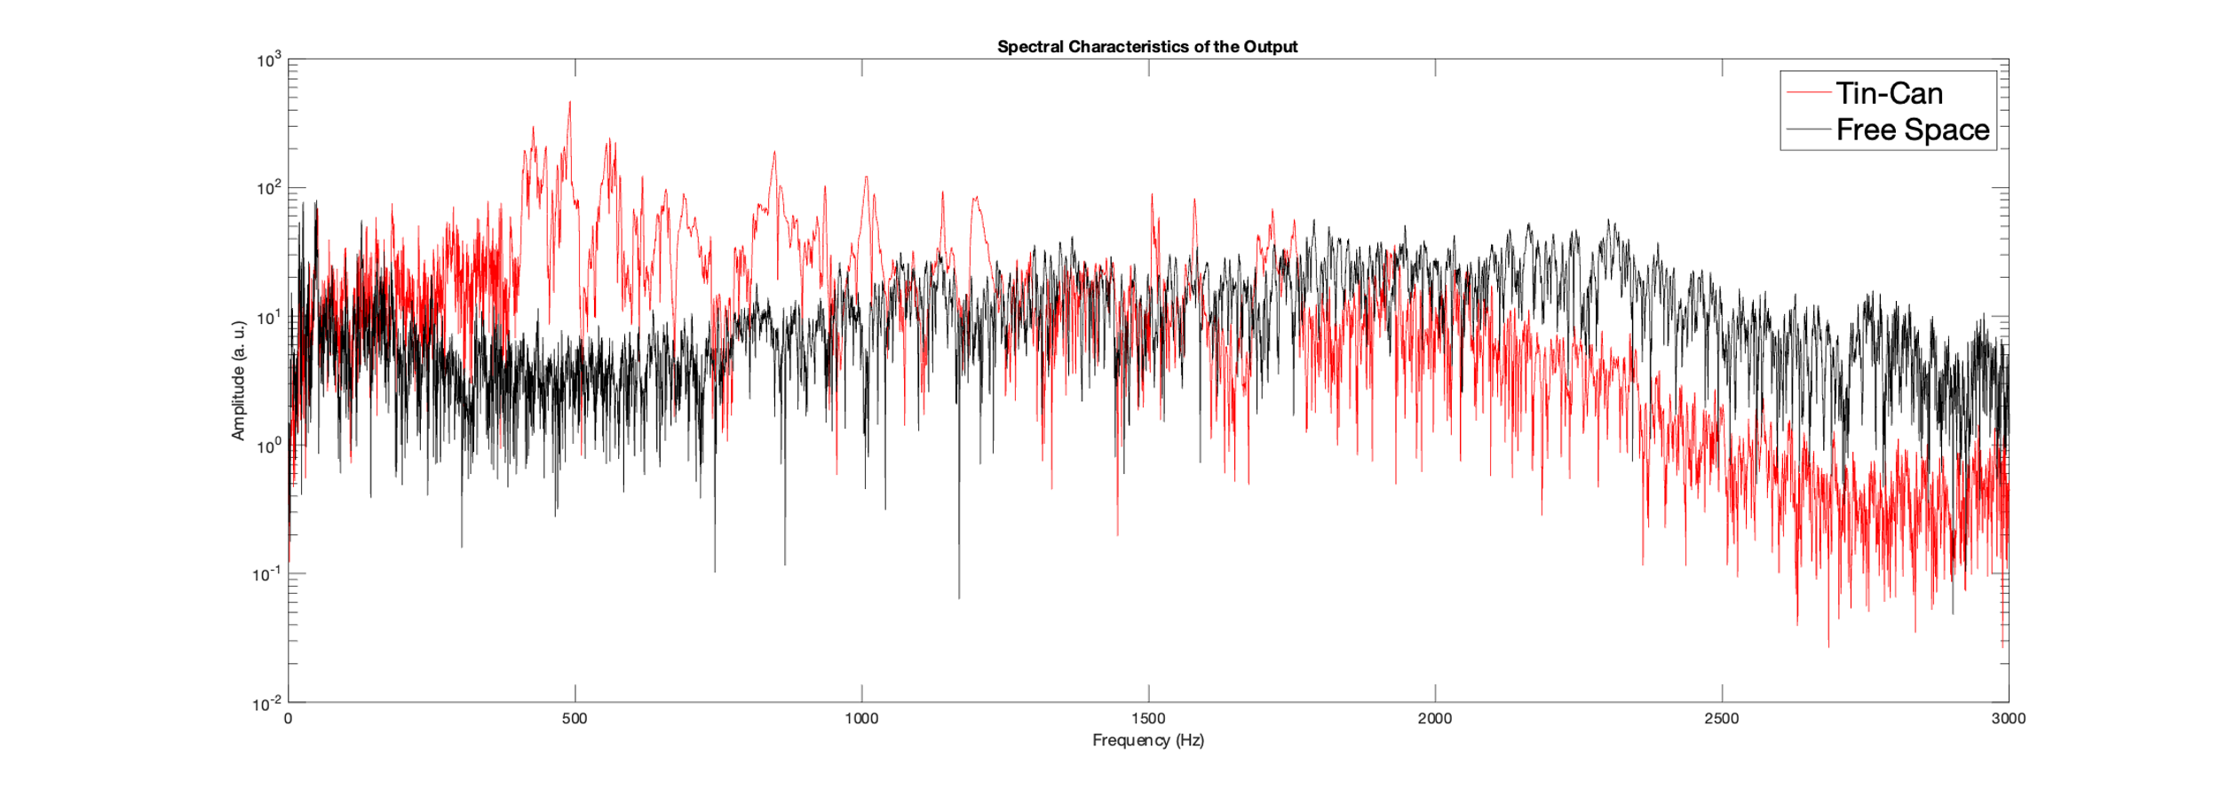

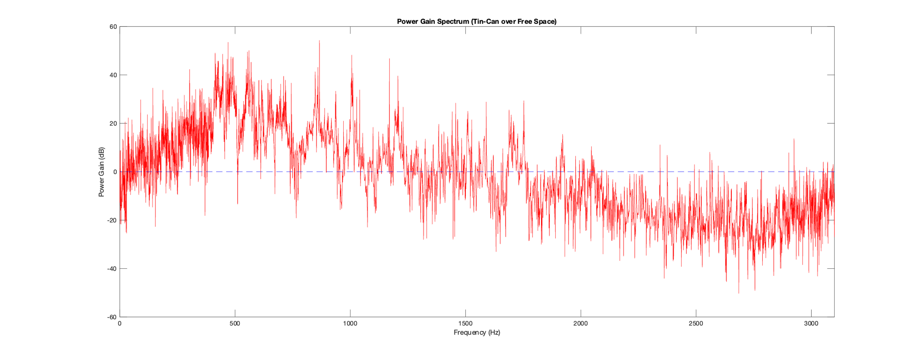

**Figure 2.** (a) Spectral Characteristic of the Output in the Transmission System and in Free Space (b) Signal Power Gain as a function of Frequency

# Conclusions

Overall performance of the experimental system was expected as we knew that the audio signal received through the tin-phone has frequency peaks similar to the natural acoustic resonance of the tin-can. However, the gain spectrum shows that frequency range of the audio signal seems to be larger than expected (400-3000Hz) due to frequencies higher than 2000Hz being detected in free space. This could be due to an error in the MATLAB code generating the audio signal. Despite that, the system is suitable for audio communications, as the frequency peaks still fall into the voice frequency ranges (300-3000Hz).

Appendix:

# Methods

*Experimental System:* Our experimental system consists of two tin cans joined with a 203.5cm long steel wire. Our testing methodology involves recording the sound of the tin can when striked. MATLAB is used to record the received audio with audiorecorder() and saves the recording using audiowrite(). Audioread() assigns values for the recording, so it can be plotted in the time domain. By using fft() and fftshift(), the signal can be plotted in the frequency domain. When setting up the experimental system, brackets and clamps are used to hold the system to keep the wire taut. The sound is generated on MATLAB using sound() and played on a speaker which is placed next to one of the cans. The opposite can is near a microphone connected to a laptop recording the audio using MATLAB. When testing in free space, the system is removed from the setup and the sound is recorded from 203.5cm away from the microphone.

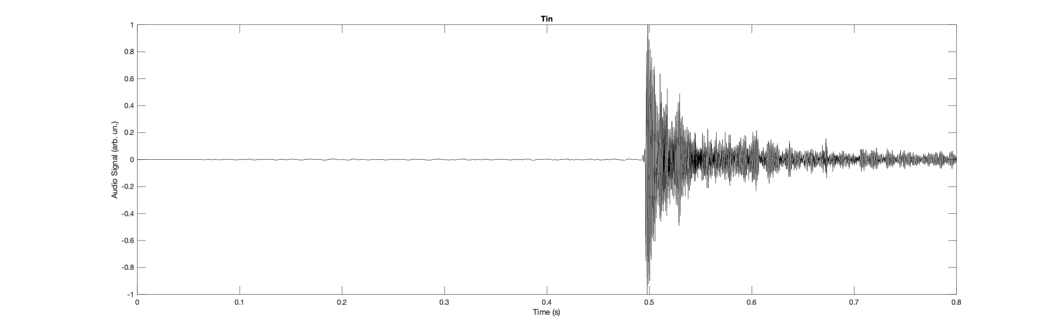

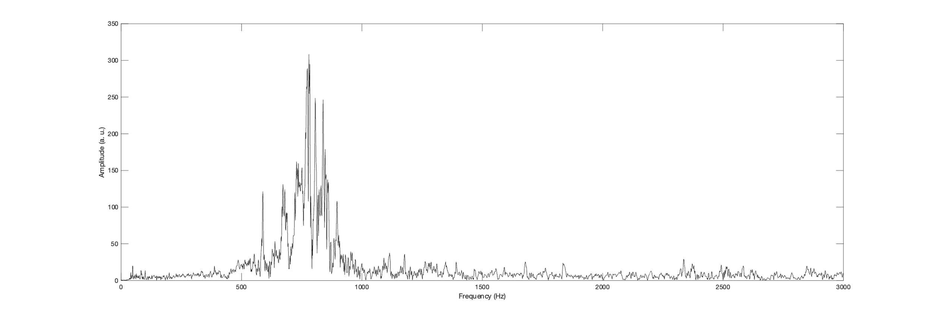**Figure A1.** (a) Audio Signal Amplitude of the receiver in the Time Domain (b) Fourier Amplitude Spectra of the receiver in the Frequency Domain

*Test Audio Signals:* The test signal used for this experiment is a chirped pulse which covers the range of voice frequencies. To generate our chirped pulse, we first created a chirped signal where the signal’s frequency increases over time. This can be done using a wave, where is a constant. This is then multiplied with a wave with a gaussian distribution, , which creates the envelope of the chirped pulse. To check the range of frequencies generated by our chirped pulse, we used the fft() and fftshift() function to plot the test audio signal in the frequency domain. By adjusting the values of σ and µ, we were able to get a chirped pulse which covered the frequency range 400-2000Hz. As the approximate range of voice frequencies is 300-3000Hz, the pulse created is within the range and meets the conditions.

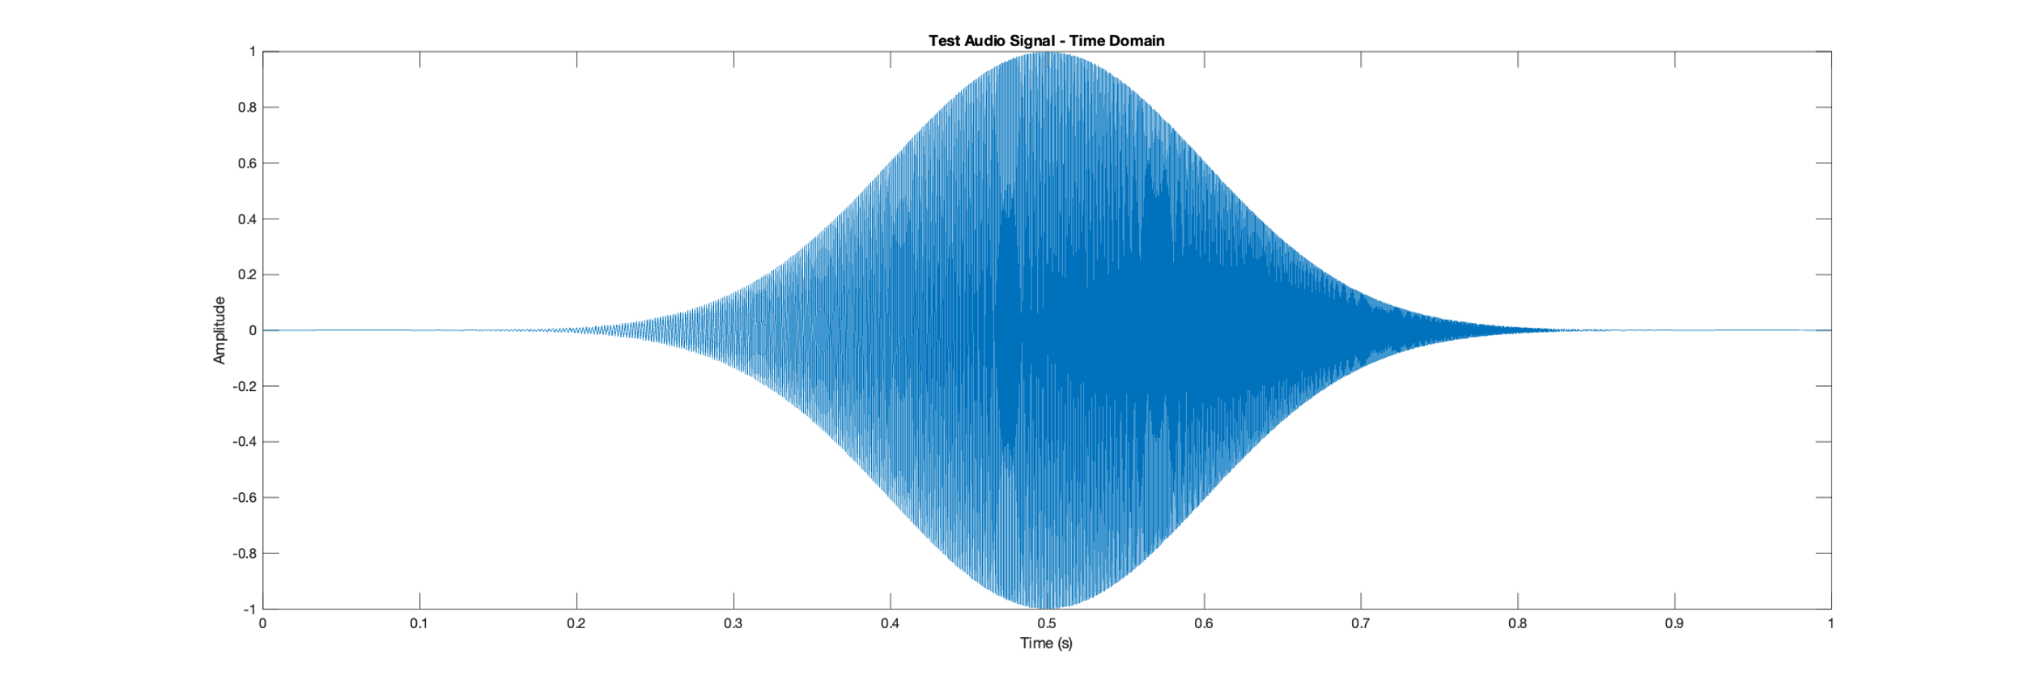

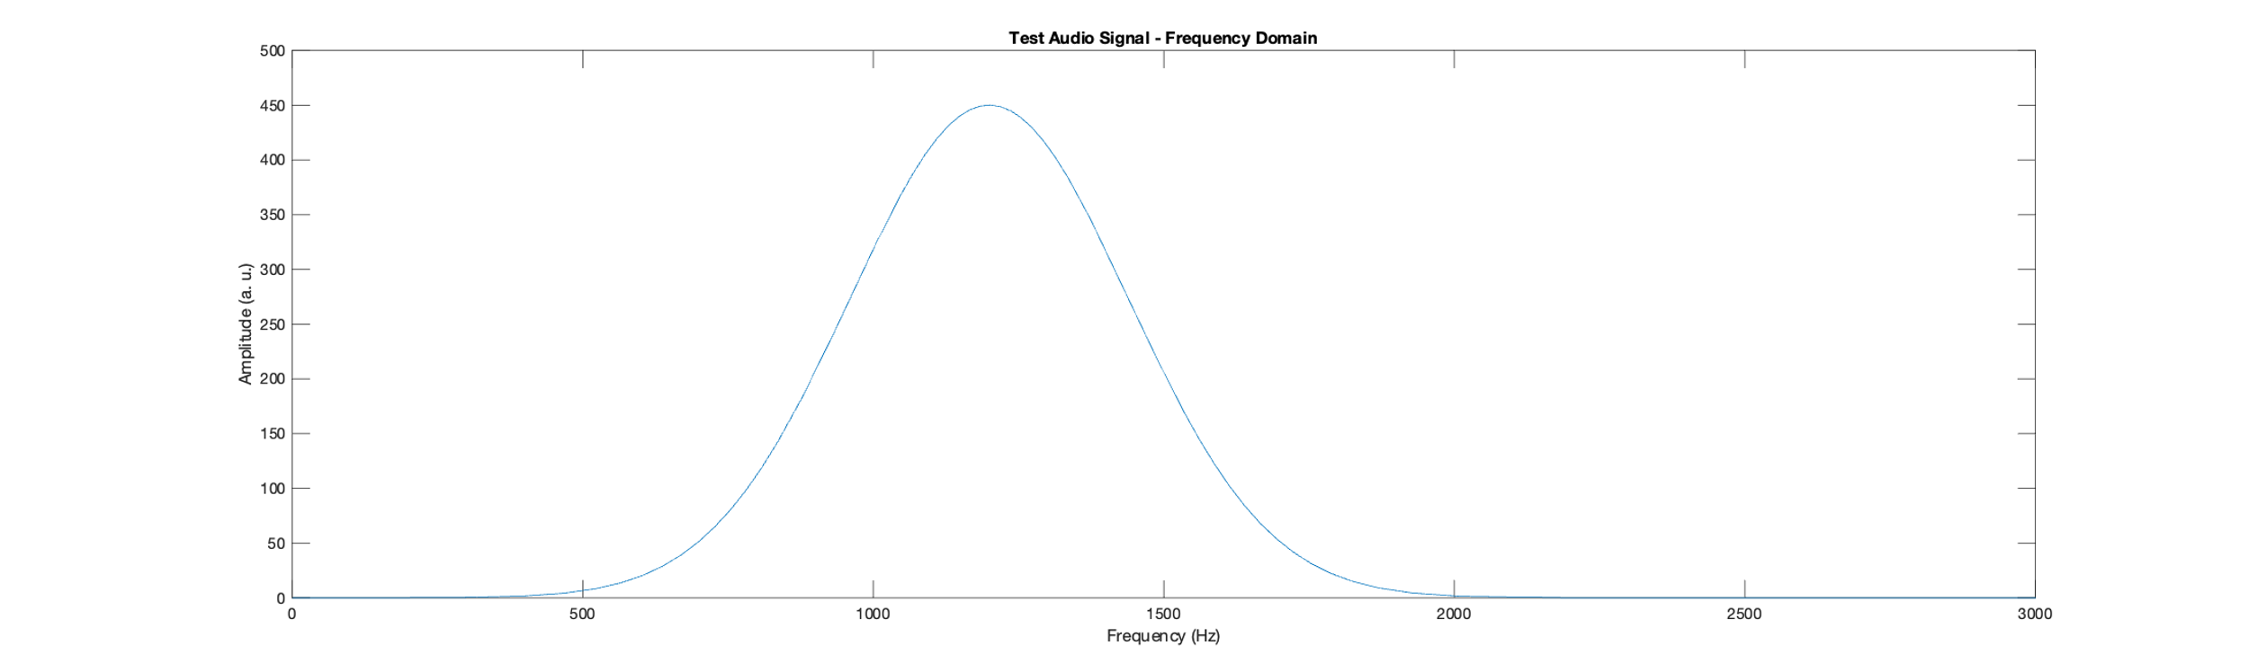

**Figure A2.** (a) Test Audio Signal in the Time Domain (b) Test Audio Signal in the Frequency Domain

# Analysis

*Transmission Spectrum of Phone System:* There is a positive gain between frequencies 400-1500Hz, showing the tin-can phone is more effective in this range, while there is negative gain in between frequencies 1750-3000Hz, showing transmission in free space is more effective in this range. The frequencies where the tin-can phone is effective is similar to the frequency response range of the spectral resolution of tin. Audio transmission in free space cannot pick up the audio signal in the range 400-1500Hz as well as the tin-can phone, however, it can still pick up frequencies outside of the spectral resolution of tin, while the tin-can phone is not able to. Since the wavelength of higher frequency sounds have a shorter wavelength, it takes more wave cycles to make it through the medium, therefore more energy is absorbed by the particles. In the tin-can phone, audio transmission happens along a solid medium, therefore the vibrations are passed along packed vibrating particles, however, the particles are more spread out in free space. There are more wave cycles occurring in the wire, however, if the particles lose all the energy in the medium, the signal will not reach the receiver. Since air has less particles, fewer wave cycles are required, and less energy is absorbed.

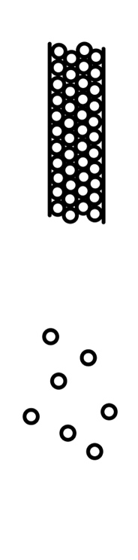

**Figure A3.** (a) Particles in the wire (b) Particles in free space

##### Team Member Contribution Statement

I am the group representitive. I helped my group with writing the MATLAB programs and plotted the graphs for the assignment, since my laptop is used to record audio. I also contributed to building the the tin-can phone and testing it in the quiet room.

##### References

1. “*The Speed of Sound in Other Materials*”, Iowa State University, <https://www.nde-ed.org/Physics/Sound/speedinair.xhtml>
2. Purves. D, Augustine. GJ, Fitzpatrick. D, “*Neurosciencce. 2nd edition*”, Sunderland, Sinauer Associates, The Audible Spectrum, 2001, <https://www.ncbi.nlm.nih.gov/books/NBK10924/>
3. “*Human Voice Frequency Range*”, Sound Engineering Academy, 2022, <https://seaindia.in/blogs/human-voice-frequency-range/>